Data: NEISS 2012, downloaded on 1/13/22.

* Currently contains only plots that I made for the data from 2012. The original dataset has 546,616 observations, but after filtering for IVP patients with only head and neck-related injuries, only 2011 observations were left for analysis.
* This doc currently includes all the plots that the ortho paper did, except that I made them based on only 2012 as opposed to aggregated data from over a period of time.
* Haven’t finished doing all the goodness-of-fit tests (mostly using Fisher’s exact test due to small expected counts; used Chi square test otherwise), but all the ones I’ve done have been insignificant. I tried pooling categories, correcting techniques, and even just dropped categories that had too little counts. But none of these measures changed the overall conclusion, even though they sometimes did improve the p-values by a little.
* Might need to discuss which variable we want to look at for logistic regression modeling. But we can talk about that later.
* In this document, I made notes on the things I would like to discuss with you. You can respond to them using a different color or by adding comments. Or we can chat over a call if you think that’s easier. You can ignore the notes preceded by “TO DO/TO FIGURE OUT” – they are for myself. They are things that don’t interfere without our analyses but will be necessary for publication. They require a little more research on the coding aspect to achieve, so I will postpone them for now to get the high-yield things done first.

# Plots

## By Diagnosis & Sex

TO-DO:

* remove the numbers in parentheses in front of the labels
* might consider turning the proportion into percentage

* Are we keeping the very small groups on the right (e.g. from “burn scald” onward)?
  + If so, I might need to figure out a way to display all the numbers that can’t be seen currently.

## By Age Group & Race

* Might consider removing the lower and upper age groups given their small group sizes
  + The ortho paper only showed ages 15 - 64
* TO-DO: move the “UNK” gray section to the bottom of each bar. Either reorder/sort the factors or reassign the name of the factors.

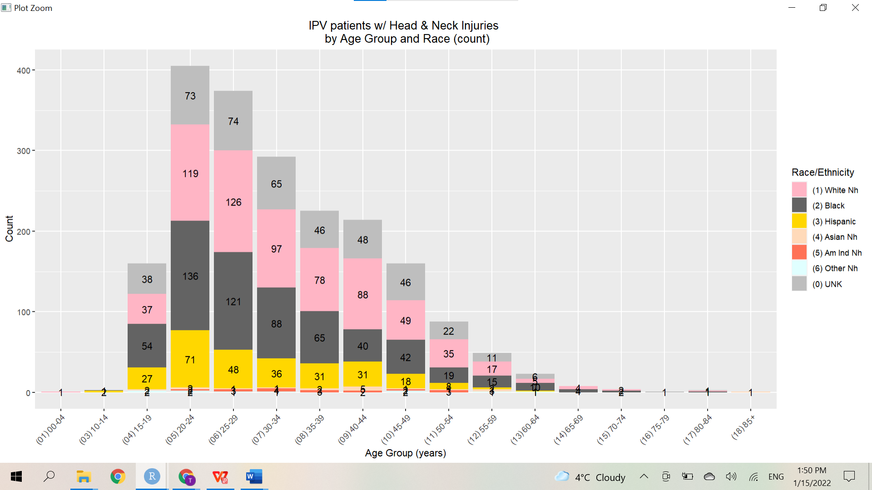

* Bars are in their original age-group order. Intentionally did not sort them by absolute count to preserve the inherent ordering of age.
* This graph confirms that it would make sense to limit our presentation to ages 15 - 64.

## By ED Disposition & Diagnosis

Prob not very useful to present either of the following graphs as is.

* The paper only showed 2 categories for ED disposition (release vs admit) and 5 diagnoses

Below: Shows only two disposition groups, (1) and (4), without any pooling.

* Might consider pooling/combining some categories, e.g. (1) and (2).
* Too many small groups. See the next graph for modification.

Below: Two disposition categories without pooling + only diagnoses with count > n

* The “proportion graph” does NOT visually highlight the idea that most IPV patients with head and neck injuries are not hospitalized.
* But in the “count graph,” the numbers in the “admitted” category become very difficult to read.

# Plots on Body Parts

The ortho paper focused one particular injury type, i.e. fracture, and plotted gender/age group/race against injured body part. Since we haven’t discussed if there’s a particular injury type we want to focus on, I made the same three plots on all injury types.

## By Gender & Body Parts

TO FIGURE OUT:

* For patient with multiple injured body parts, how are they counted in this dataset?

## By Age Group & Body Parts

Below: all age groups included

Below: included only age groups from 15-64

## By Race & Body Parts

* Exclude the last three race groups?